New: LION V 6040
Pöttinger adds 6.0 m model to medium weight folding power harrows
This power harrow range featuring the folding LION V series is designed for tractors up to 320 hp. What's new is that Pöttinger - the arable farming specialist – is expanding the series up to a working width of 6.0 m. The speed of the rotors can be matched to the site-specific conditions.

LION V 4040, LION V, 5040 and LION V 6040 medium weight folding power harrows focus on the compactness of the machine and optimised weight distribution. These folding power harrows are designed to be operator friendly by providing a perfect overview of the entire machine to simplify monitoring and control.

Short and compact design
Integrating the folding frame into the two power harrow beams makes the machine more compact and optimises weight distribution. The result is an extremely short and compact power harrow that is much shorter than any of its competitors. The centre of gravity is now closer to the rear axle and the weight acting on the front axle is noticeably more positive. Road transport is no problem because the LION V folds up to an outer width of 2.55 m.

The solution for the toughest conditions
The new changeable speed gearbox offers a wide range of speeds. The LION V series is designed for PTO speeds between 540 and 1000 rpm. This ensures that the tractor always runs within its optimum performance range, and reliability is enhanced as a result. A high-capacity gearbox housing provides the necessary cooling.
The rotor speeds vary between 342 and 415 rpm, to deliver perfect working results while reducing fuel consumption. The power harrow is approved for tractors up to 320 hp.
Easy machine adjustment
Adjustments are made without the need for tools from the side of the machine, and an intuitive indicator scale acts as a guide. All that is needed is to pull out a lynch pin and adjust the control rod to set the working depth as required. This system allows the working depth to be adjusted at intervals of approx. one centimetre. Fully hydraulic working depth adjustment is also available as an option.

Convenient levelling board linkage
An impressive and much appreciated advantage is offered by the levelling board, which is automatically height adjusted by the rear roller. This is completely independent of working depth adjustment. The levelling board is guided at a consistent pre-defined distance above the soil without changing its distance from the tines or its pre-set height. This patented solution creates the most level and uniform tilth structure for the seedbed, even in varying soil conditions.

Choice of rollers for every type of soil
Seedbed preparation is concluded by one of a wide range of rear rollers. There is a choice of two tooth packer rollers and two prism packer rollers as well as a pack ring roller. On the tooth packer rollers and prism packer rollers there are two different diameters to chose from. The range has been extended to include a crumbling-packer roller for working widths of 5.0 m and 6.0 m.

Combined with a Pöttinger AEROSEM FDD seed drill, this machine becomes a high output and cost effective combination delivering perfect sowing results. Featuring easy attachment to the tractor, this is the perfect solution for farmers with high specifications, for today and into the future.

At the same time as extending the medium weight LION V range, the heavy folding power harrows have been given a facelift. The new LION V 6030 MASTER with a working width of 6.0 m features all the latest updates.

Photo preview:
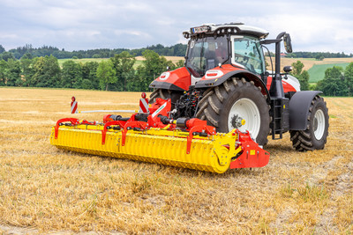 | 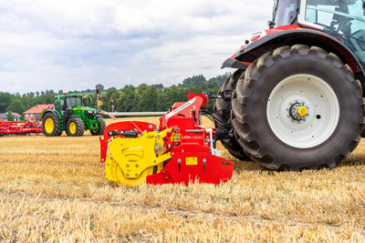
LION V 6040, the solution for the toughest conditions | Die LION V 6040 features an impressive short design and optimised weight distribution
https://www.poettinger.at/de_at/newsroom/pressebild/150591 | https://www.poettinger.at/de_at/newsroom/pressebild/150590

More printer-optimised photos: www.poettinger.at/presse

